**A PROJECT REPORT**

**ON**

**“**Women safety and emergency application”

IN THE FULFILLMENT OF THE REQUIREMENTS

FOR THE AWARD

OF

**DIPLOMA IN COMPUTER ENGINEERING**

**(2020-2021)**

**BY**

|  |  |  |
| --- | --- | --- |
| **Roll No** | **Student Name** | **Batch** |
| 6109 | Prajwal Kadam | CO-1 |
| 6116 | Sahil Pardeshi | CO-1 |
| 6149 | Tushar More | CO-1 |
| 6118 | Pranay Sable | CO-1 |

## AISSMS-POLY-NEW-logo

**DEPARTMENT OF COMPUTER ENGINEERING**

**AISSMS’S POLYTECHNIC**

**KENNEDYROAD**

## PUNE 411001

**ALL INDIA SHRI SHIVAJI MEMERIAL SOCIETY’S POLYTECHNIC, PUNE -1**

**COMPUTER ENGINEERING DEPARTMENT** 

**VISION AND MISSION OF THE INSTITUTE**

* **VISION:**

Achieve excellence in quality technical education by imparting knowledge, skills and abilities to build a better technocrat.

* **MISSION:**

1. Empower the students by inculcating various technical and soft skills.
2. Upgrade teaching-learning process and industry-institute interaction continuously.

**VISION AND MISSION OF THE COMPUTER DEPARTMENT**

* **VISION:**

“Enhance skills by providing value based technical education for fulfilling global needs in the field of computer engineering.”

* **MISSION:**

1. To provide quality education in computer engineering by improving psychomotor skills.
2. To develop positive attitude, communication skills, team spirit and entrepreneurship.
3. To develop awareness about societal and ethical responsibility for professionalism.

**ALL INDIA SHRI SHIVAJI MEMORIAL SOCIETY’S POLYTECHNIC, PUNE -1**

**COMPUTER ENGINEERING DEPARTMENT** __________________________________________________________________________

**PROGRAM OUTCOMES (POs)**

|  |  |
| --- | --- |
| **PO1:** | **Basic knowledge:** An ability to apply knowledge of basic mathematics, science and engineering to solve the Computer engineering problems. |
| **PO2:** | **Discipline knowledge:** An ability to apply discipline - specific knowledge to solve core and/or applied Computer engineering problems. |
| **PO3:** | **Experiments and practice:** An ability to plan and perform experiments and practices and to use the results to solve Computer engineering problems. |
| **PO4:** | **Engineering Tools:** Apply appropriate Computer Engineering technologies and tools with an understanding of the limitations. |
| **PO5:** | **The engineer and society:** Demonstrate knowledge of Computer Engineering to assess societal, health, safety, legal and cultural issues and the consequent responsibilities relevant to standard engineering practice. |
| **PO6:** | **Environment and Sustainability**: Understand the impact of the Computer engineering solutions in societal and environmental contexts, and demonstrate the knowledge and need for sustainable development. |
| **PO7:** | **Ethics**: Apply ethical principles and commit to professional ethics and responsibilities and norms of the engineering practice in the field of Computer Engineering. |
| **PO8:** | **Individual and team work:** Function effectively as an individual, and as a member or leader in diverse/multidisciplinary teams. |
| **PO9:** | **Communication**: An ability to communicate effectively in verbal and written. |
| **PO10:** | **Life-long learning:** Recognize the need for, and have the preparation and ability to engage in the Independent and lifelong learning in the context of technological changes in the field of Computer Engineering. |

**PROGRAM SPECIFIC OUTCOMES (PSO)**

The Diploma in Computer Engineering will prepare students to attain:

* **PSO 1:** Apply computing knowledge with standard practices to develop software.
* **PSO 2:** Maintain Computer Hardware and Software System



**CERTIFICATE**

This is to certify that Mr. / Ms. ………………………………………………………….. from **AISSMS Polytechnic, Pune** Institute having Enrollment No.:……………………………………………………………………………………..has completed Project of final year having title “Women safety and emergency application” during the academic 2020-2021. The project completed by in group consisting of four persons under the guidance of the faculty Guide.

|  |  |  |
| --- | --- | --- |
| **Prof. V. R. Sonar**  Project Guide | **Prof. S.K. Giram**  Principal  AISSMS Polytechnic | **Prof. V. N. Kukre**  HOD  Computer Engineering Department |
|  |  |  |

## ACKNOWLEDGEMENT

With an immense pleasure and satisfaction, I am presenting this Project report as part of the curriculum of Diploma Computer Engineering. I wish to express my sincere gratitude towards all those who have extended their support right from the stage this idea was conceived.

I am profoundly grateful to **Prof. V. R. Sonar** , Project Guide, for her expert guidance and continuous encouragement throughout to see that project work right its target since its commencement to its completion.

I am thankful to **Prof. A. N. Gedam**, Project Coordinator, for conducting and supporting such research activities.

I am also grateful to **Prof. V. N. Kukre**, HOD, Department of Computer Engineering, for his support and encouragement.

Finally, I am also grateful to Honorable **Prof. S. K. Giram**, Principal, AISSMS POLYTECHNIC, Pune, for his support and guidance that have helped me to expand my horizons of thought and expression.

|  |  |
| --- | --- |
| **Roll No** | **Name** |
| 6109 | PRAJWAL S. KADAM |
| 6116 | SAHIL S. PARDESHI |
| 6149 | TUSHAR D. MORE |
| 6118 | PRANAY R. SABLE |

**Abstract**

Safety for women is one of the most pressing issues of our time that should have been a fundamental, undeniable concept for any civilized society centuries ago. Denying fundamental rights to safety, personal choices, freedom to pursue whatever lifestyle they wish to, sexual and physical empowerment are not new issues — but have strangely not managed to be eradicated even in today’s times.

A lot of people have been crying out loud for better ways to ensure women's security and make things better for them. And it seems like, not only people but we are also trying to do something about it.

Now finally, there’s an app that promises to add its drop into the ocean to ensure safety for women that’s completely designed for the general public.

# INDEX

|  |  |  |
| --- | --- | --- |
| Chapter no | Contents | Page No |
| 1 | Introduction | 9-11 |
| 2 | Literature Survey | 12 |
| 3 | Scope of Project | 13-14 |
| 4 | Methodology | 15-21 |
| 5 | Details of designs, working and processes | 23-27 |
| 6 | Result and Applications | 28-39 |
| 7 | Conclusions and future scope | 40 |
| 8 | Publications | 41-57 |
| 9 | References and Bibliography | 58-59 |

**Chapter 1**

**INTRODUCTIOn**

**1.0 Idea of Project:**

We got the idea of this project when we were doing some work on Computer. We read news about women harassment cases in news and we thought this would be a great idea to develop an application which can empower women and help them in case of emergency. Hod sir motivated us to create application on android platform as most of smartphone users are on android platform

* 1. **Motivation of project:**

While setting up the genuine undertaking and report of the equivalent, we had a disarray and that how we'll begin the venture and what we'll do in the event that it doesn't work consummately, etc. Absence of inspiration was ascending in our gathering yet our venture manage guided us and encouraged us in finding the right sources which are needed to achieve our task. First we thought we’ll complete our project using kotlin language but after studing kotlin a little bit deeper, we’ve got to know that java is more easy and fast and more efficient language as compare to kotlin. At that point we turned towards java and in the wake of picturing the code and the bundles that are available in java language we got completely energized and roused to do futher exercises to finish our venture.In this way, first we suffered from demotivation but after some time we were fully focused and motivated for the completion of our project.

**1.3 OVERVIEW:**

The need for a women safety and panic alert app is, unfortunately, increasing in the current societies across the world. One of the biggest roles that have been played in ensuring the safety of women has to be the digital transformation and advancement in technology. Especially in the world where 3 out of every 5 people have smartphones and use dozens of mobile apps every day. There’s a one-time registration that requires the user(s) to fill out their details and that of the emergency contacts. Many situations occur when people don’t have internet connection So we came with solution in terms of our application which works with and without internet services. An Android app which can INSTANTLY alert guardians (Along with user location) whenever the user is in an emergency situation. On the mobile device even shaking the phone thrice will trigger the app to register it as an emergency.

Immediately, your emergency contacts, as well as the local security authorities, will be notified that you are in an emergency situation along with exact GPS coordinates.

The key features of our app that makes it different from other apps designed till now are as follows:

1) Initially, we have to enter the two contact numbers of police, family members and friends in to the application say and click on

“save” button.

2) While travelling, run the application and whenever need arises, click “start” button/toggle button.

3) As soon as “start” button pressed, it firsts make a call to the first saved registered contact number and also sends the message

containing location URL of the victim to all the contact numbers.

4) Unique feature of this app is message with location URL is sent continuously to the registered contact numbers for every five

minutes until “stop” button is clicked. So, continuous location tracking of victim is possible with this application

And after this we are going to do Web Scraping and get live news and not some historical data or news. Which will make our system 99% Accurate.

**1.4 BRIEF DESCRIPTION:**

The need for a women safety and panic alert app is, unfortunately, increasing in the current societies across the world. One of the biggest roles that have been played in ensuring the safety of women, has to be the digital transformation and advancement in technology. Especially in the world where 3 out of every 5 people have smartphones and use dozens of mobile apps every day.

There’s a one-time registration that requires the user(s) to fill out their details and that of the emergency contacts. Many situations occur when people don’t have internet connection So we came with solution in terms of our application which works with and without internet services. An Android app which can INSTANTLY alert guardians (Along with user location) whenever the user is in an emergency situation.. On the mobile device even shaking the phone thrice will trigger the app to register it as an emergency.

Immediately, your emergency contacts, as well as the local security authorities, will be notified that you are in an emergency situation along with exact GPS coordinates At that time the pictures are capture in front and rear, siren will be ringing and also siren ringing in emergency contact if they are registered

**Unique points**:

* The app doesn’t require internet data/WiFi to work. In most emergency situations, users will not be in a position to have internet working or switch it on or wait for a signal, this is a unique factor the app.
* The user can add a local crime/alert in the app so that people around that place can view the alert and take action.
* The app has a feature to view alerts on the map with time, date, and pictures.
* Works on all mobile networks

**Chapter 2**

**Literature Survey**

* A mobile-based women safety application is developed with the Android support to know whether a woman is safe. It gives the location of the woman in danger and inform to the registered number and police authorities
* Women feel unsafe to travel alone at odd hours. We got inspiration of this application from reading about incidences happen in our country . Our inspiration include research on various topics related to android application development, mobile center, location and GPS setting, transmission of location to user,etc
* At any emergency situation people get panicked and in that situation, they may not be able to operate their smartphone applications, and cannot immediately defend the attacker and protect themselves.
* The proposed system can be useful for women and children for security purpose.the propose system will use smartphone sensor like accelerometer , gyrometer,etc. to determine if the women is in danger and inform to the registered number and police authorities.

|  |  |  |  |  |  |  |  |  |  |  |  |  |  |  |  |  |  |  |  |  |  |  |  |  |  |  |  |  |  |  |  |  |  |  |  |  |  |  |  |  |  |  |  |  |  |  |  |  |  |  |  |  |  |  |  |  |  |  |  |  |  |  |  |  |  |  |  |  |  |  |  |  |  |  |  |  |  |  |  |  |  |  |
| --- | --- | --- | --- | --- | --- | --- | --- | --- | --- | --- | --- | --- | --- | --- | --- | --- | --- | --- | --- | --- | --- | --- | --- | --- | --- | --- | --- | --- | --- | --- | --- | --- | --- | --- | --- | --- | --- | --- | --- | --- | --- | --- | --- | --- | --- | --- | --- | --- | --- | --- | --- | --- | --- | --- | --- | --- | --- | --- | --- | --- | --- | --- | --- | --- | --- | --- | --- | --- | --- | --- | --- | --- | --- | --- | --- | --- | --- | --- | --- | --- | --- | --- |
| **Chapter 3**  **Scope of the project**  **3.1. problem definition:**  Women empowerment is our ajenda which can be fullfilled by our application and be a crucial tool for all women in danger. At any emergency situation people get panicked and in that situation, they may not be able to operate their smartphone applications, and cannot immediately defend the attacker and protect themselves. The proposed system can be useful for women and children for security purpose.the propose system will use smartphone sensor like accelerometer , gyrometer,etc. to determine if the women is in danger and inform to the registered number and police authorities  **Overview of responsibilities of Developer**  The team comprises of 4 members for development of the product. We all have different sets of knowledge, experiences regarding latest technologies and languages.  1.Pranay R. Sable : Documentation and most of the non-technical work.  2.Prajwal S. Kadam: Technical planning and coding, Documentation  3.Sahil S. Pardeshi : Technical planning and coding, Documentation  4.Tushar D. More : Non-Technical planning and coding, Documentation  Modern life has become quite convenient and the people of the world have to thank the immense contribution of the internet technology for communication and information sharing. There is no doubt that internet has made our lives easier and access to surplus information viable . But this information can be generated and manipulated by common folks in bulk and the spread of such data is reckless due to the presence of social media. Platforms like Facebook and Twitter have allowed all kinds of questionable and inaccurate “news” content to reach wide audiences without proper monitoring. Social media users bias toward believing what their friends share and what they read regardless of authenticity allow these fake stories to propagate widely through and across multiple platforms and increase their credibility.  **3.2 scope of the project:**  Future scope of our project can include live tracking of application users using cloud and maps GSM.Servers to enhance the precision of the tool and also provide 24x7 support for emergency services.Also local police authority and hospitals can have live data of users to track any incidents that may happen in their areas .Support for offline usage of the app so that it can be used even in remote areas which have scarcity of network coverage  **3.3Resource Requirements**:  a) Hardware Requirements:   |  |  | | --- | --- | | 1. System | Pentium IV 2.4 GHz. | | 1. Hard Disk | 500gb | | 1. Mobile OS | .Android | | 1. Monitor | 15 VGA Colour. | | 1. Mouse | Microsoft optical | | 1. Ram | 3gb |   **SOFTWARE CONTEXT:**   |  |  |  | | --- | --- | --- | | **Sr. No.** | **Resource** | **Configuration** | | 1. | Operating System | Windows 10 | | 2. | Coding Language | Java | | 3. | Software | Android studio 4.1 |   **Chapter 4**  **Methodology**  **4.0 PROJECT PLAN:**  **4.1 PROJECT ESTIMATES:**  The estimation of project can be carried out depending upon the feasibility study of all the service (i.e. modules) which is included in our project. The numbers of automation tools, Function points are used for calculations of estimate. Since with the feasibility study for our project, it can be designed and developed within 7-8 months. The different stages like communication, planning, modelling, construction and deployment of waterfall model are used at every stage.  **Reconciled Estimates**   * Requirement analysis requires 2months. * Literature Survey requires 1 month. * Feasibility study and analysis requires 1 month. * Implements and testing requires 3 months. * Deployment requires 1 month.   **COST ESTIMATE:**  Cost of a project is estimated using current estimation models such as automation tools which allow us to estimate cost as a function of size. Thus, it also allows us to estimate and analyse the feasibility of competition of the system in given time frame. As this project is developed completely using software applications, the expenditure during development are only the efforts made by the developer for the successful completion of the project.  **TIME ESTIMATES:**  Since with the feasibility study for our project, it can be designed and developed within 7-8 months. The different stages like communication, planning, modeling, construction and deployment of waterfall model are used at every stage.   |  |  |  | | --- | --- | --- | | **S.R.No** | **Date** | **Project Activity** | | 1. | 26/06/2020 – 30/06/2020 | Decide project group member | | 2. | 01/07/2020 – 03/07/2020 | Submitted 3 Project Topic with base Papers | | 3. | 04/07/2020 – 06/07/2020 | Discuss 5 point analysis of selected base Papers | | 4. | 07/07/2020 – 10/07/2020 | 3 Topics are presented and 1 topic selected | | 5. | 11/08/2020 | Created and Submitted project proposal of a selected project | | 6. | 15/08/2020 – 20/09/2020 | Progressive Assessment and Preparation Presentation on synopsis | | 7. | 04/10/2020 | Presentation | | 8. | 10/12/2020 – 02/01/2021 | Literature Survey and info gathering of a selected | | 9. | First week of January | Project progress presentation | | 10. | 10/01/2020 – 25/01/2020 | Project implementation with UML diagrams | | 11. | First week of February | 70 percent project implementation | | 12. | First week of March | 100 percent project completion done with testing | | 13. | Second week of March | paper published | | 14. | Third week of March | Project report |   **Project Plan**  **4.1 Schedule Work:**  Design is multi-step process that focuses on data structure software architecture, procedural details, (algorithms etc.) and interface between modules.  Gantt chart    **4.3 SOFTWARE TESTING:**  **Manual Test:**  Manual and Automated test are the types of software testing. We are doing a manual test for testing our system that is without using any automated tool or any script. In this type tester takes over the role of an end user and test the software to identify any unexpected behavior or bug. There are different stages for manual testing like unit testing, integration testing, system testing and user acceptance testing. Testers use test plan, test cases or test scenario to test the software to ensure the completeness of a testing. Manual testing also includes exploratory testing as a testers explore the software to identify the errors in it.  **Automated Test:**  Automation testing which is also known as Test Automation is when the tester writes scripts and  uses software to test the software. This process involves automation of a manual process. Automation Testing is used to re-run the test scenarios that were performed manually, quickly and repeatedly.  **1) White Box Testing:**  Sometimes called glass-box testing is a test case design method that uses the control structure of  the procedural design to derive test cases. Using white-box testing methods, the software engineer can derive test cases that  (1) Guarantee that all independent paths within a module have been exercised at least once,  (2) Exercise all logical decisions on their true and false sides,  (3) Execute all loops at their boundaries and within their operational bounds, and  (4) Exercise internal data structures to ensure their validity.  White-box testing of software is predicated on close examination of procedural detail by unit and integration testing. Providing test cases that exercise specific sets of conditions and/or loops tests logical paths through the software. The status of the program may be examined at various points to determine if the expected or asserted status corresponds to the actual status. Basis path testing is a white-box testing technique first proposed by Tom McCabe. The basis path method enables the test case designer to derive a logical complexity measure of a procedural design and use this measure as a guide for defining a basis set of execution paths. Test cases derived to exercise the basis set are guaranteed to execute every statement in the program at least one time during testing. In this system, the system was tested for the calculation matters were the data provided for giving the right output or not. If wrong data was provided then what it is throwing error or accepting.  C:\Users\admin\Desktop\Capstone Project\chart1.png  **2) Black Box Testing:**  Also called behavioral testing, focuses on the functional requirements of the software. That is, black box testing enables the software engineer to derive sets of input conditions that will fully exercise all functional requirements for a program. Black box testing is not an alternative to white-box techniques. Rather, it is a complementary approach that is likely to uncover a different class of error than white-box methods. When computer software is considered, black box testing Alludes to tests that are conducted at the software interface. Although they are designed to uncover errors, black-box tests are used to demonstrate that software functions are operational, that input is properly accepted and output is correctly produced and that the integrity of external information is maintained. A black-box test examines some fundamental aspect of a system with a little regard for the internal logical structure of the software. Black-box testing attempts to find errors in the following categories:  6. Incorrect or missing functions  7. Interface errors  8. Errors in data structures or external database access  9. Behavior or performance errors  10. Initialization and termination errors  By applying back-box techniques, a set of test cases that satisfy the following criteria are derived:  Test cases that reduce, by a count that is greater than one, the number of additional test cases that  must be designed to achieve reasonable testing. Test cases that tell us something about the presence or absence of classes of errors, rather than an error associated only with the specific test at hand.  White-box testing should not, however, be dismissed as impractical. A limited number of important logical paths can be selected and exercised. Important data structures can be probed for validity. The attributes of both black and white box testing can be combined to provide an approach that validates the software interface and selectively ensures that the internal workings of the software are correct. Black box testing for this system was done to check the internal testing i.e., the system is working properly in each case or no. What kind of errors are there in database design. To find out faults, mistakes there is use of different black box testing methods like system testing, performance testing, load testing, etc.  C:\Users\admin\Desktop\Capstone Project\Dash1.png  **3)System testing:**  System testing is testing the whole system. It follows the scope of black box testing which doesn’t require any knowledge of design of code or logic. It performs to test the fulfillment of functional requirement specification (FRS) and software requirement specification (SRS). It tests about graphical user interface, usability, performance, compatibility, exception handling, load, volume, stress, security, accessibility, failure and recovery etc.   |  |  | | --- | --- | | 1. System | Pentium IV 2.4 GHz. | | 1. Hard Disk | 500gb | | 1. Mobile OS | .Android | | 1. Monitor | 15 VGA Colour. | | 1. Mouse | Microsoft optical | | 1. Ram | 3gb |   **4) Performance testing:**  Any software should be a quality software and quality measures by using the attributes reliability, scalability and resource usage. Performance testing is the general testing which determine how system performs? This is in terms of responsiveness and stability under maximum workload. Proposed system gives positive response to performance testing. It works properly and give proper output for large number of database. Resource usage is also maximum. The only thing is for very large amount of database system performance i.e computation time of system get increased.  C:\Users\admin\Desktop\Capstone Project\performance testing.pngC:\Users\admin\Desktop\Capstone Project\performance-testing-report-compare.png |  |

**Chapter 5**

**Details of designs, working and processes**

**5.0 USE CASE DIAGRAM (overall working):**

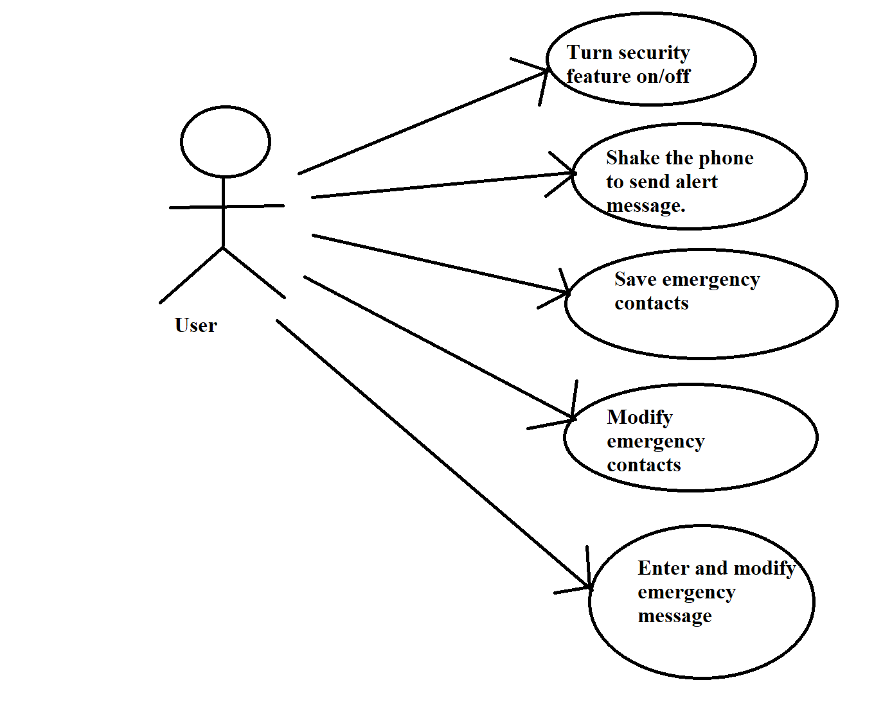

Fig:

Use cases are a way to capture system functionality and requirements in UML. Use case diagrams consist of named pieces of functionality (use cases), the persons or things invoking the functionality (actors), and possibly the elements responsible for implementing the use cases (subjects).

**DATA FLOW DIAGRAM**

The different data objects with their relationship are explained below using E-R(Entity-Relation)model. Many data objects are explained in details with their relations with other data objects and attributes

.

**5.1 DATA FLOW DIAGRAM:**

DFD level 0

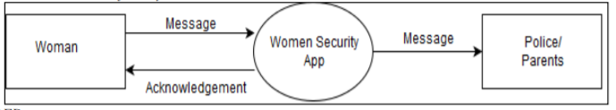

**5.2 DFD Context Level**

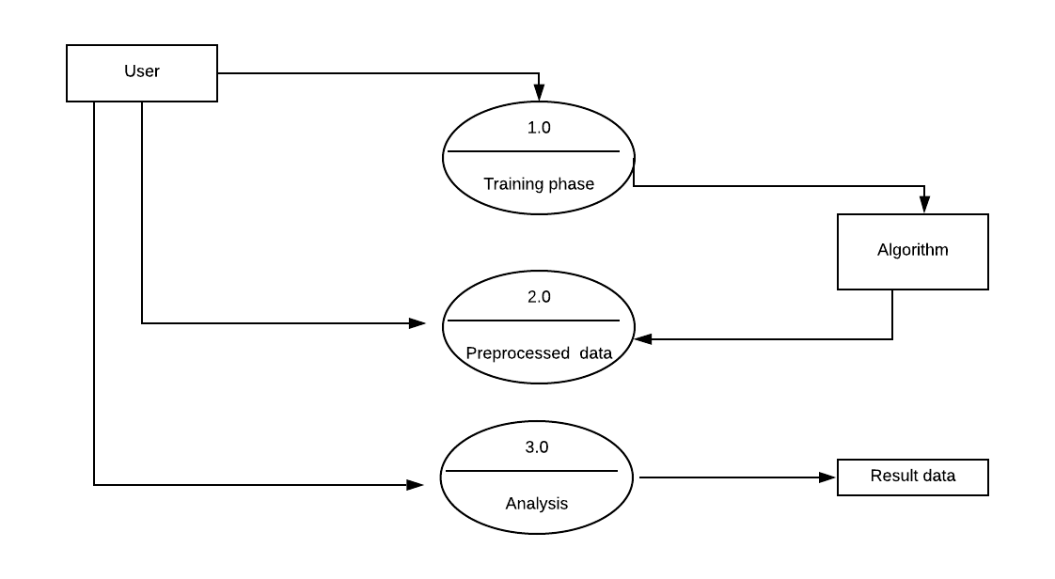

**5.4 ACIVITY DIAGRAM:**

\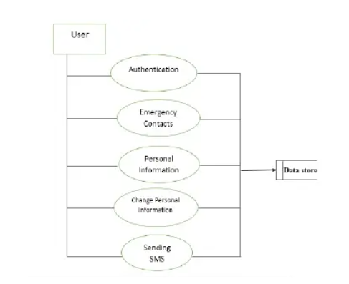

Activity modelling focuses on the execution and flow of the behaviour of a system, rather than how it is assembled. Possibly more than any other UML diagram, activity diagrams apply to much more than just software modelling. They are applicable to just about any type of behavioural modelling; for example, business processes, software processes, or workflows. Activity diagrams capture activities that are made up of smaller actions.

**5.6 SYSTEM ARCHITECTURAL DIAGRAM :**

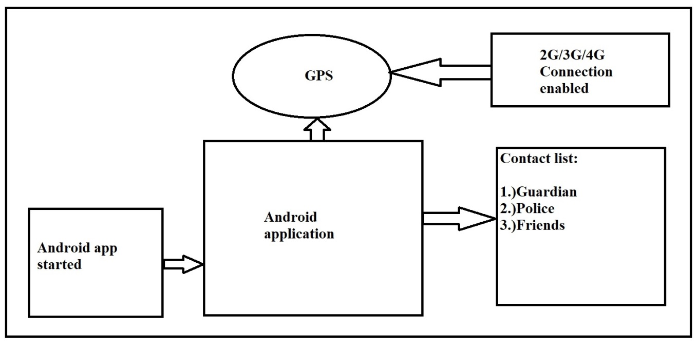

**5.7 SEQUENCE DIAGRAM :**

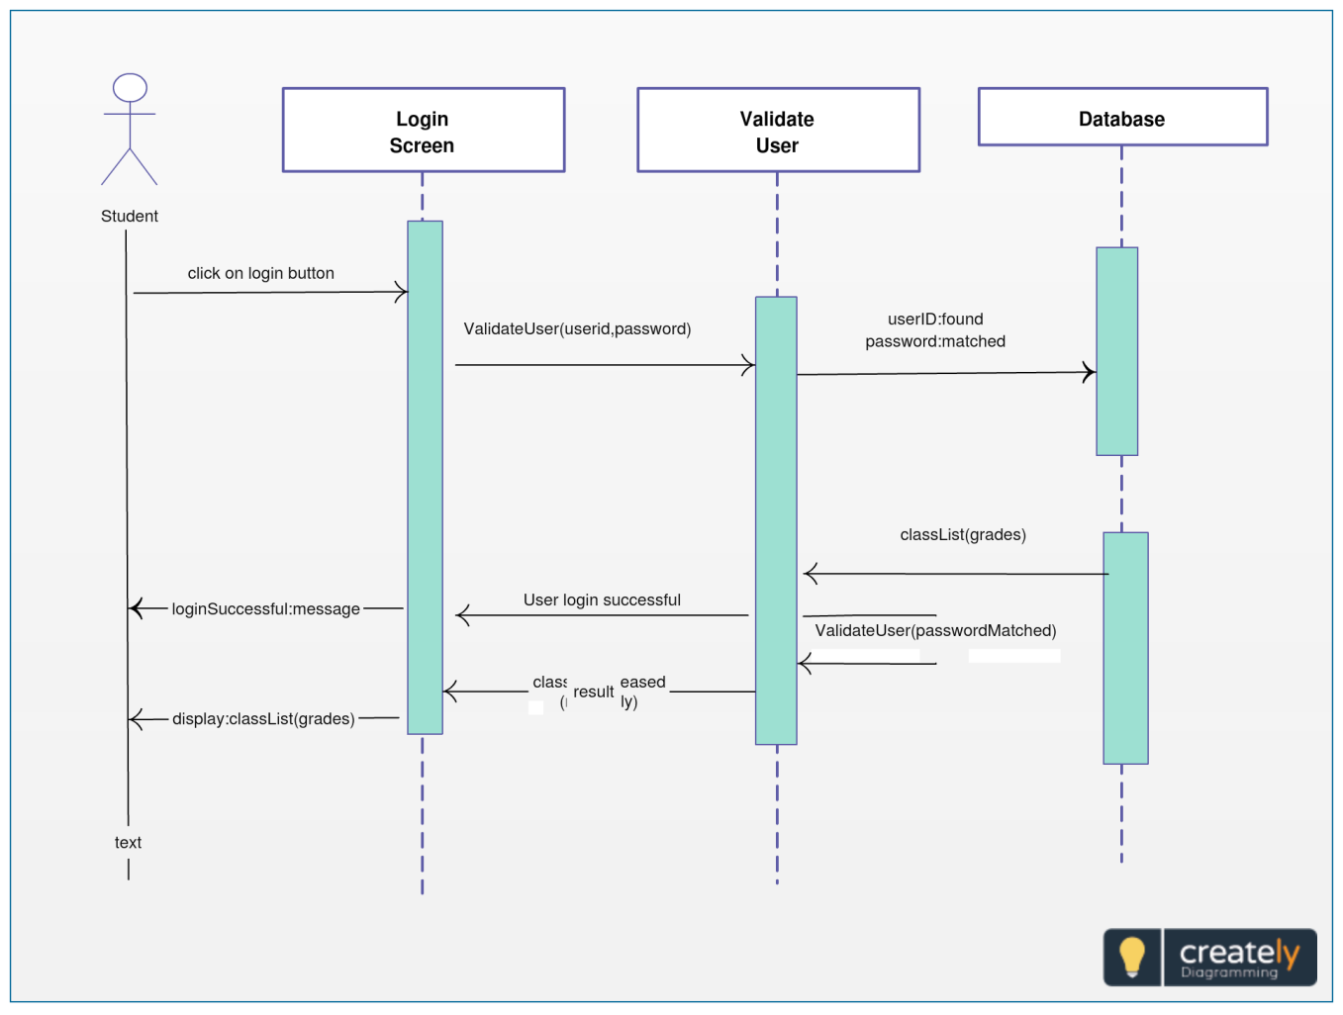

**Chapter 6**

**Results of The Project**

**6.0 Snapshots:**

**1) Activity window of the application:**

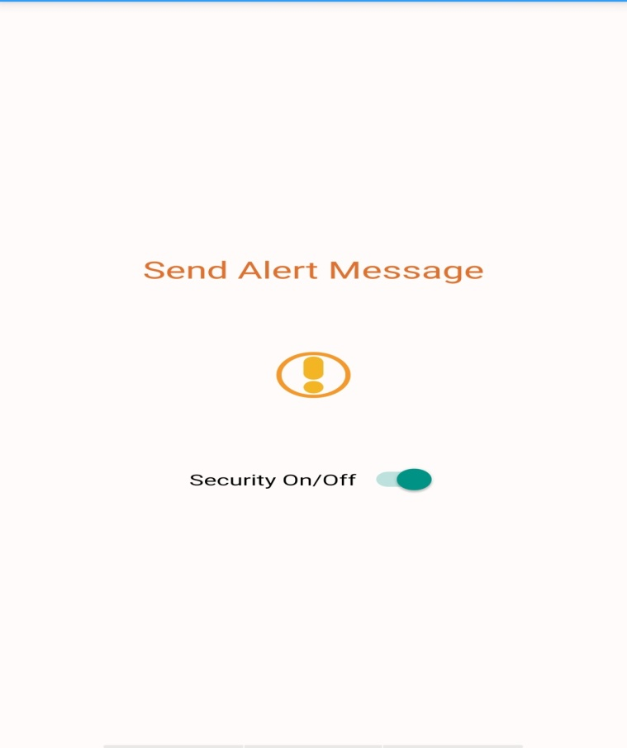

**2)** **The page to save emergency contact numbers and save them:**

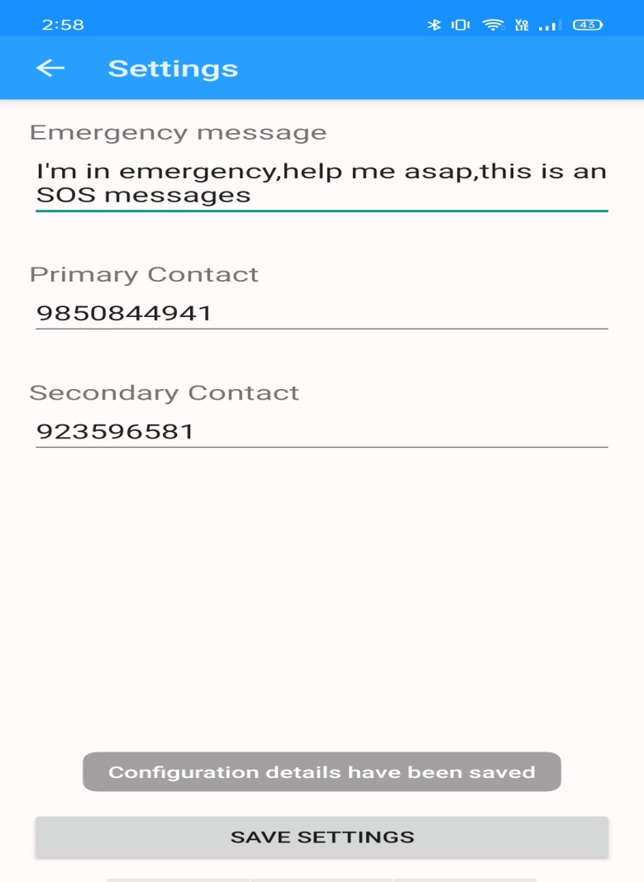

**3) The message delivered to the saved contact numbers**.

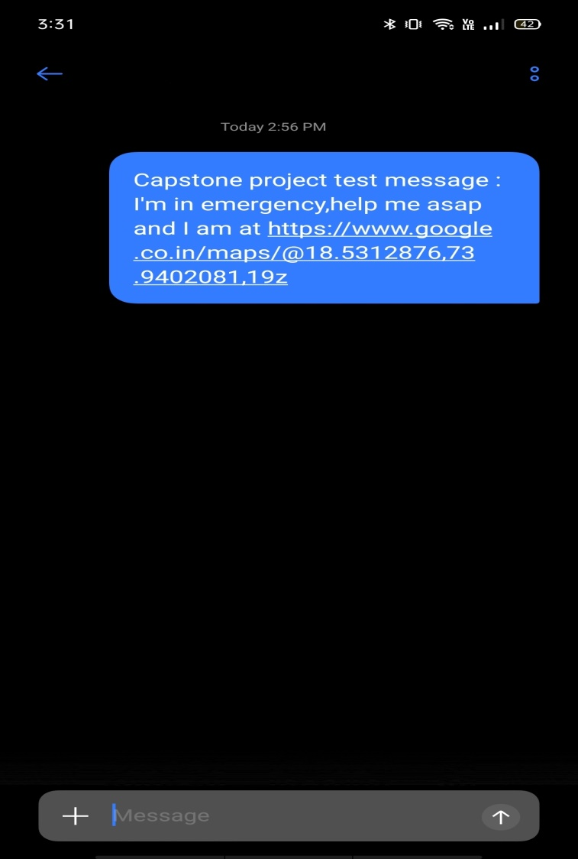

**4) Current location of the user from the test message**:

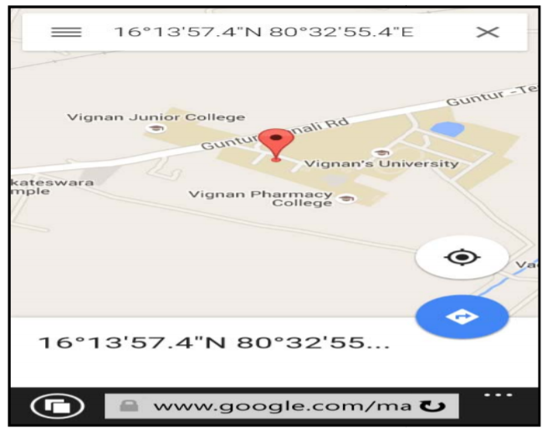

**3) Output:**

Package com.example.abhaya;  
  
import android.app.Activity;  
import android.content.Intent;  
import android.content.SharedPreferences;  
import android.content.pm.PackageInfo;  
import android.content.pm.PackageManager;  
import android.support.v7.app.ActionBarActivity;  
import android.support.v7.app.ActionBar;  
import android.support.v4.app.Fragment;  
import android.support.v4.app.FragmentManager;  
import android.content.Context;  
import android.os.Build;  
import android.os.Bundle;  
import android.telephony.SmsManager;  
import android.util.Log;  
import android.view.Gravity;  
import android.view.KeyEvent;  
import android.view.LayoutInflater;  
import android.view.Menu;  
import android.view.MenuItem;  
import android.view.View;  
import android.view.ViewGroup;  
import android.support.v4.widget.DrawerLayout;  
import android.widget.ArrayAdapter;  
import android.widget.CompoundButton;  
import android.widget.Switch;  
import android.widget.TextView;  
import android.widget.Toast;  
  
  
public class AbhayaMainActivity extends ActionBarActivity  
        implements NavigationDrawerFragment.NavigationDrawerCallbacks,CompoundButton.OnCheckedChangeListener {  
  
  
  
  
    /**  
     * Fragment managing the behaviors, interactions and presentation of the navigation drawer.  
     */  
    private NavigationDrawerFragment mNavigationDrawerFragment;  
  
    /**  
     * Used to store the last screen title. For use in {@link #restoreActionBar()}.  
     */  
    private CharSequence mTitle;  
    SharedPreferences sharedPreferences;  
    SettingsActivity settingsActivity;  
  
    @Override  
    protected void onCreate(Bundle savedInstanceState) {  
        super.onCreate(savedInstanceState);  
        setContentView(R.layout.activity_abhaya_main);  
  
        //Context context = getApplicationContext();  
        //sharedPreferences = context.getSharedPreferences(settingsActivity.MyPreferences, 0);  
        //SharedPreferences.Editor editor = sharedPreferences.edit();  
  
        mNavigationDrawerFragment = (NavigationDrawerFragment)  
                getSupportFragmentManager().findFragmentById(R.id.navigation_drawer);  
        mTitle = getTitle();  
        settingsActivity = new SettingsActivity(AbhayaMainActivity.this);  
        // Set up the drawer.  
        mNavigationDrawerFragment.setUp(  
                R.id.navigation_drawer,  
                (DrawerLayout) findViewById(R.id.drawer_layout));  
        //Switch Code here...  
        Switch securityOnOff = (Switch) findViewById(R.id.security_on_off);  
        Boolean security = settingsActivity.checkSecurity();  
        String securityState = (security) ? "ON" : "OFF";  
        Toast.makeText(this,"Security is " + securityState, Toast.LENGTH_LONG).show();  
        securityOnOff.setChecked(security);  
  
  
        //Toast.makeText(this, "Security Current Position " + (securityOnOff.isChecked() ? "On" : "Off"),Toast.LENGTH_SHORT).show();  
        if (securityOnOff != null) {  
            securityOnOff.setOnCheckedChangeListener(this);  
        }  
  
  
    }  
  
    @Override  
    public void onCheckedChanged(CompoundButton button, boolean isChecked){  
        Context context = getApplicationContext();  
        sharedPreferences = context.getSharedPreferences(settingsActivity.MyPreferences, 0);  
        SharedPreferences.Editor editor = sharedPreferences.edit();  
        if(isChecked){  
            editor.putBoolean(settingsActivity.securityOnOffs, true);  
            Toast.makeText(this, "Security is ON", Toast.LENGTH_LONG).show();  
        } else {  
            editor.putBoolean(settingsActivity.securityOnOffs, false);  
            Toast.makeText(this, "Security is OFF", Toast.LENGTH_LONG).show();  
        }  
        editor.commit();  
    }  
//    @Override  
//    public void startService(view View){  
//        startService(new Intent(getBaseContext(), BackGroundServices.class));  
//    }  
//  
//    @Override  
//    public void stopService(view View){  
//        stopService(new Intent(getBaseContext(), BackGroundServices.class));  
//    }  
  
    @Override  
    public void onNavigationDrawerItemSelected(int position) {  
        // update the main content by replacing fragments  
        FragmentManager fragmentManager = getSupportFragmentManager();  
        fragmentManager.beginTransaction()  
                .replace(R.id.container, PlaceholderFragment.newInstance(position + 1))  
                .commit();  
    }  
  
    public void onSectionAttached(int number) {  
        switch (number) {  
            case 1:  
                mTitle = "HERA 2.0";  
                break;  
            case 2:  
                mTitle = "HERA 2.0";  
                break;  
        }  
    }  
  
    public void restoreActionBar() {  
        ActionBar actionBar = getSupportActionBar();  
        actionBar.setNavigationMode(ActionBar.NAVIGATION_MODE_STANDARD);  
        actionBar.setDisplayShowTitleEnabled(true);  
        actionBar.setTitle(mTitle);  
    }  
  
  
    @Override  
    public boolean onCreateOptionsMenu(Menu menu) {  
        if (!mNavigationDrawerFragment.isDrawerOpen()) {  
            // Only show items in the action bar relevant to this screen  
            // if the drawer is not showing. Otherwise, let the drawer  
            // decide what to show in the action bar.  
            getMenuInflater().inflate(R.menu.abhaya_main, menu);  
            restoreActionBar();  
            return true;  
        }  
        return super.onCreateOptionsMenu(menu);  
    }  
  
    @Override  
    public boolean onOptionsItemSelected(MenuItem item) {  
        // Handle action bar item clicks here. The action bar will  
        // automatically handle clicks on the Home/Up button, so long  
        // as you specify a parent activity in AndroidManifest.xml.  
        int id = item.getItemId();  
  
        //noinspection SimplifiableIfStatement  
  
        return super.onOptionsItemSelected(item);  
    }  
  
    /**  
     * A placeholder fragment containing a simple view.  
     */  
    public static class PlaceholderFragment extends Fragment {  
        /**  
         * The fragment argument representing the section number for this  
         * fragment.  
         */  
        private static final String ARG_SECTION_NUMBER = "section_number";  
  
        /**  
         * Returns a new instance of this fragment for the given section  
         * number.  
         */  
        public static PlaceholderFragment newInstance(int sectionNumber) {  
            PlaceholderFragment fragment = new PlaceholderFragment();  
            Bundle args = new Bundle();  
            args.putInt(ARG_SECTION_NUMBER, sectionNumber);  
            fragment.setArguments(args);  
            return fragment;  
        }  
  
        public PlaceholderFragment() {  
        }  
  
        @Override  
        public View onCreateView(LayoutInflater inflater, ViewGroup container,  
                                 Bundle savedInstanceState) {  
            View rootView = inflater.inflate(R.layout.fragment_abhaya_main, container, false);  
            return rootView;  
        }  
  
        @Override  
        public void onAttach(Activity activity) {  
            super.onAttach(activity);  
            ((AbhayaMainActivity) activity).onSectionAttached(  
                    getArguments().getInt(ARG_SECTION_NUMBER));  
        }  
    }  
  
    /* Function Name : shareWithWhatsApp(View view)  
       Usage : Send Message through WhatsApp via intent  
     */  
    public void shareWithWhatsApp (View view){  
        Context context = getApplicationContext();  
        GPSTracker gpsTracker = new GPSTracker(context);  
        //Boolean checkInternet = checkInternetConnection(context);  
        sharedPreferences = context.getSharedPreferences(settingsActivity.MyPreferences,  
                0);  
        SmsManager smsManager = SmsManager.getDefault();  
        Boolean security = sharedPreferences.getBoolean(settingsActivity.securityOnOffs, false);  
        String message = sharedPreferences.getString(settingsActivity.Messages, null);  
        String pContact = sharedPreferences.getString(settingsActivity.pContacts, null);  
        String sContact = sharedPreferences.getString(settingsActivity.sContacts, null);  
        if(security) {  
                if (sharedPreferences.contains(settingsActivity.Messages)) {  
  
                        String urlWithPrefix = "";  
                        if(gpsTracker.isGPSEnabled) {  
                            String stringLatitude = String.valueOf(gpsTracker.latitude);  
                            String stringLongitude = String.valueOf(gpsTracker.longitude);  
                            urlWithPrefix = " and I am at <https://www.google.co.in/maps/@>" + stringLatitude + "," + stringLongitude + ",19z";  
                        }else{  
                            Toast.makeText(context,"Your GPS is OFF", Toast.LENGTH_LONG).show();  
                        }  
                    /* WhatsApp Intent will come here */  
                    PackageManager pm=getPackageManager();  
                    try {  
  
                        Intent waIntent = new Intent(Intent.ACTION_SEND);  
                        waIntent.setType("text/plain");  
                        String text = "YOUR TEXT HERE";  
  
                        PackageInfo info=pm.getPackageInfo("com.whatsapp", PackageManager.GET_META_DATA);  
                        //Check if package exists or not. If not then code  
                        //in catch block will be called  
                        waIntent.setPackage("com.whatsapp");  
  
                        waIntent.putExtra(Intent.EXTRA_TEXT, text);  
                        startActivity(Intent.createChooser(waIntent, "Share with"));  
  
                    } catch (PackageManager.NameNotFoundException e) {  
                        Toast.makeText(this, "WhatsApp not Installed", Toast.LENGTH_SHORT)  
                                .show();  
                    }  
                    /* WhatsApp Intent code will end here */  
                } else {  
                    Toast.makeText(context,  
                            "You haven't setup any Emergency Message in ABHAYA App",  
                            Toast.LENGTH_LONG).show();  
                }  
        } else {  
            Toast.makeText(context,  
                    "Your Security is OFF in ABHAYA App",  
                    Toast.LENGTH_LONG).show();  
        }  
  
  
    }  
    /* Function Name : sendMessage (View view)  
       Usage : Send SMS to configured Number with GPS Location if it is on  
     */  
    public void sendMessage (View view){  
        Context context = getApplicationContext();  
        GPSTracker gpsTracker = new GPSTracker(context);  
        //Boolean checkInternet = checkInternetConnection(context);  
        sharedPreferences = context.getSharedPreferences(settingsActivity.MyPreferences,  
                0);  
        SmsManager smsManager = SmsManager.getDefault();  
        Boolean security = sharedPreferences.getBoolean(settingsActivity.securityOnOffs, false);  
        String message = sharedPreferences.getString(settingsActivity.Messages, null);  
        String pContact = sharedPreferences.getString(settingsActivity.pContacts, null);  
        String sContact = sharedPreferences.getString(settingsActivity.sContacts, null);  
        if(security) {  
            if (sharedPreferences.contains(settingsActivity.pContacts) || sharedPreferences.contains(settingsActivity.sContacts)) {  
                if (sharedPreferences.contains(settingsActivity.Messages)) {  
                    if (sharedPreferences.contains(settingsActivity.pContacts)) {  
                        String urlWithPrefix = "";  
                        if(gpsTracker.isGPSEnabled) {  
                            String stringLatitude = String.valueOf(gpsTracker.latitude);  
                            String stringLongitude = String.valueOf(gpsTracker.longitude);  
                            urlWithPrefix = " and I am at <https://www.google.co.in/maps/@>" + stringLatitude + "," + stringLongitude + ",19z";  
                        }else{  
                            Toast.makeText(context,"Your GPS is OFF", Toast.LENGTH_LONG).show();  
                        }  
  
                        if (pContact != null && !pContact.isEmpty()) {  
                            message = message + urlWithPrefix;  
                            smsManager.sendTextMessage(pContact, null, message, null, null);  
                            Toast.makeText(context, "Message sent : " + pContact, Toast.LENGTH_LONG).show();  
  
                            if(sContact != null && !sContact.isEmpty()){  
                                String url = (pContact != null && !pContact.isEmpty()) ? "" : urlWithPrefix;  
                                message = message + url;  
                                smsManager.sendTextMessage(sContact, null, message, null, null);  
                                Toast.makeText(context, "Message sent : " + sContact, Toast.LENGTH_LONG).show();  
                            }  
  
                        } else {  
                            Toast.makeText(context,  
                                    "Please setup Primary Contact in ABHAYA App",  
                                    Toast.LENGTH_LONG).show();  
                        }  
  
                    } else {  
                        Toast.makeText(context,  
                                "Please setup Primary Contact in ABHAYA App",  
                                Toast.LENGTH_LONG).show();  
                    }  
                } else {  
                    Toast.makeText(context,  
                            "You haven't setup any Emergency Message in ABHAYA App",  
                            Toast.LENGTH_LONG).show();  
                }  
            } else {  
                Toast.makeText(context,  
                        "Please Configure contact details in ABHAYA App",  
                        Toast.LENGTH_LONG).show();  
            }  
        } else {  
            Toast.makeText(context,  
                    "Your Security is OFF in ABHAYA App",  
                    Toast.LENGTH_LONG).show();  
        }

\

**Chapter 7**

**Conclusion and Future Scope**

**7.0 CONCLUSION:**

At any emergency situation people get panicked and in that situation, they may not be able to operate their smartphone applications, and cannot immediately defend the attacker and protect themselves. The proposed system can be useful for women and children for security purpose.the propose system will use smartphone sensor like accelerometer , gyrometer,etc. to determine if the women is in danger and inform to the registered number and police authorities. Future scope of our project can include live tracking of application users using cloud and maps GSM.Servers to enhance the precision of the tool and also provide 24x7 support for emergency services.Also local police authority and hospitals can have live data of users to track any incidents that may happen in their areas .Support for offline usage of the app so that it can be used even in remote areas which have scarcity of network coverage.

**FUTURESCOPE**

* Future scope of our project can include live tracking of application users using cloud and maps GSM. Servers to enhance the precision of the tool and also provide 24x7 support for emergency services.
* Also local police authority and hospitals can have live data of users to track any incidents that may happen in their areas.
* Support for offline usage of the app so that it can be used even in remote areas which have scarcity of network coverage.

**Chapter 8**

**Publication**

**A survey on women’s safety and emergency application**

Mrs V R Sonar1,Prajwal Kadam2, Sahil Pardeshi3,Tushar More4,Pranay Sable5

1Lecturer at AISSMS Polytechnic

2,3,4,5Final year student of diploma, Computer Engineering Department,

AISSMS Polytechnic, Kennedy Road, Near R.T.O, Pune - 411001, Maharashtra, India

ABSTRACT: Safety for ladies is one among the foremost pressing problems with our time that ought to are a fundamental, undeniable concept for any civilized society centuries ago. Denying fundamental rights to safety, personal choices, freedom to pursue whatever lifestyle they wish to, sexual and physical empowerment are not new issues — but have strangely not managed to be eradicated even in today’s times. A lot of individuals are crying aloud for better ways to make sure women's security and make things better for them. And it seems like, not only people but we are also trying to do something about it. Now finally, there’s an app that promises to feature its drop into the ocean to make sure safety for ladies that’s completely designed for the overall public.

KEYWORDS: Women’s Safety, Mobile Application, Emergency, GPS (Global Positioning System), Android.

1. **Introduction**

The need for women’s safety and panic alert app is, unfortunately, increasing within the current societies across the planet. One of the biggest roles that have been played in ensuring the safety of women has to be the digital transformation and advancement in technology. Especially in the world where 3 out of every 5 people have smartphones and use dozens of mobile apps every day.

There’s a one-time registration that requires the user(s) to fill out their details and that of the emergency contacts. Many situations occur when people don’t have internet connection So we came with solution in terms of our application which works with and without internet services. An Android app which can INSTANTLY alert guardians (Along with user location) whenever the user is in an emergency situation.. On the mobile device even shaking the phone thrice will trigger the app to register it as an emergency. Immediately, your emergency contacts, as well as the local security authorities, will be notified that you are in an emergency situation along with exact GPS coordinates.

The key features of our app that makes it different from other apps designed till now are as follows:

1. Initially, we have to enter the two contact numbers of police, family members and friends in to the application say and click on “save” button.
2. While travelling, run the application and whenever need arises, click “start” button/toggle button.
3. As soon as “start” button pressed, it firsts make a call to the first saved registered contact number and also sends the message containing location URL of the victim to all the contact numbers.
4. Unique feature of this app is message with location URL is sent continuously to the registered contact numbers for every five minutes until “stop” button is clicked. So, continuous location tracking of victim is possible with this application.
5. **RELATED WORK**

As a part of literature survey, we investigated some applications that offer the same or similar services for android and other platforms.

[1] The aim is to see how these applications work and to see how they can be improved. Today the cases of atrocities on women are growing. In these types of cases, a smart phone plays an important role for safety of women. Now android is budding on some apps for women security purpose. These apps are as follows:

1. Fightback: This app is developed by Mahindra faction. In earlier days, this app was not complimentary, customer have to compensate for this app. But after Delhi gang rape incident, this app is on hand at no cost. This app sends a message to your friend or contacts that “user is in trouble” through E-mail, SMS and GPRS. This app works on those mobiles that support Android Java Programming. [2]

2. Secureme Beta: This app is developed by Think MPI Consulting Private Limited. It helps us to raise alert and we can get help in case of life threatening emergencies. After installing the app, initially we have to give a pin number for security purpose and then after emergency contacts must be registered in the app. By pressing a tap on secure button, it notifies the contacts with location coordinates. [3]

3. Vanitha Alert: This app is developed by ABC Mobile Learning Communication click on '' HELP” button on our mobile's home screen in an emergency situation can deliver a distress text message to the registered mobile number ,E-mail id, face book id seeking help and indicating the user's location.[4]

4. Raksha – Women Safety Alert: This app is launched by BJP on May 15, 2014. By clicking on this app, it sends location of the user to the contacts registered and the user can also get the details of the location of the contacts. A distress signal just by pressing a single key sends out a loud buzzer to our near and dear ones. We can add multiple contacts to this app and when there is no data connection, this app alerts the contacts by sending SMS. [5]

5. Glympse – Share GPS Location: This is the recent application developed on January 28, 2015. This app is a fast, free and a simple way to share our location using GPS tracking in real time with friends and family. This app does not need any sign up and do not need any contacts to manage. [6]

6. Guardly: This app is developed basically for women safety intention, to put a phone call by your name, instantaneous location, and emergency hit to your selected friends. In this app you have to give your details in profile sheet e.g. birth date, tallness, weight, eye-colour, blood group, hair-colour, etc. This app is also used in I-Phone, I-Pad, BlackBerry, Windows Phone etc. [7]

7. Street Safe: This application is developed on worldwide Women’s day. It will call community to help woman in any situation and has four features for crisis which would be started by just clicking on the button. These features are as – First, it automatically updates on your Face book account with your recent location. Second, SMS will be sent to chosen associates with your locality. Third, an alarm is started with large volume on your mobile. Fourth, call is to be found to your chosen emergency number.[8]

iii. **METHODOLOGY**

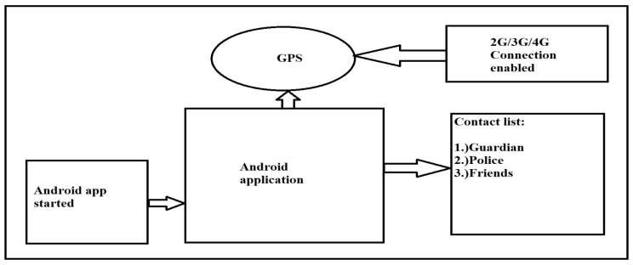

Figure 1: Block diagram of the application.

“Fig 1” shows the block diagram of the system. Initially, when we click on the app, it first checks whether the location settings, data connection settings in the application are on or not. Then, it tracks the location of the victim via GPS and sends these location co- ordinates in the form of URL through message to the registered contacts. Here, registered contacts means the contact details that are saved in the Abhaya application during its initialisation. Now, at the received device, by clicking on the URL in the message, it spots the exact location of the victim. Also, as the message containing victim’s location is sent for every five minutes from the root device, the victim can be tracked wherever she goes and can be rescued safely and quickly.

To develop this system for android users for keeping track through multiple applications. This application uses global positioning system (GPS) for identifying the location of the user in panic/trouble situation and the system can be divided into two modules:

1. First module can be the victim’s phone i.e. the root device which uses 4G/3G/2G data connection for tracking the location of the victim through GPS.

2. Second module can be the mobile phone of registered contacts either police or friends or family members which receives the message containing URL of location of victim that is sent from the root device.

The following images depict the data flow diagrams of the application:

The following are the data flow diagrams of the proposed system that depict how the data flows in the android application:



Figure 2: DFD Level 1.

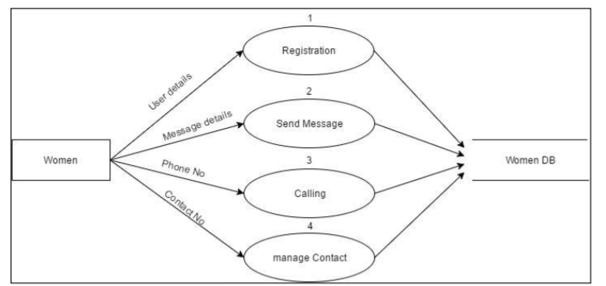

Figure 3: DFD Level 2.

1. **ACKNOWLEDGEMENT**

The satisfaction that accompanies that the successful completion of any task would be incomplete without the mention of people whose ceaseless cooperation made it possible, whose constant guidance and encouragement crown all efforts with success. We are grateful to our project guide Mrs. V R Sonar for the guidance, inspiration and constructive suggestions that helped us in the preparation of this project. We also thank our colleagues who have helped in successful completion of the project. We thank our principal S. K. Giram, our HOD Mr V N Kukre for their constant help and assistance.

.

1. **CONCLUSION**

We have implemented women’s safety and emergency application an automatic message alert system for android Our algorithm successfully detects the user’s command and reacts to it appropriately by sending alerts. We have deployed our application on many android devices and found that it successfully send alerts in emergency situation.

**References**

1. IEEE paper 2020 ,title: IOT Based Women Security: A Contemplation.
2. Report of the Fourth World Conference on Women. New York, United Nations, 1995 (A/CONF.177/20/Rev.1) (http://www.un.org/womenwatch/confer/beijing/reports/, accessed 1 April 2013).
3. World Health Organization, “Global and regional estimates of violence against women: prevalence and http://www.mappsafe.com/blog-1-feb-14-three-reasons-why-mobile-technology-will-reduce-violence-against-women.
4. Nicole Westmarland, Mariann Hardey, et al. “Protecting Women‟s Safety? The use of smartphone „apps‟ in relation to domestic and sexual violence‟, Durham University, Durham centre for research into violence and abuse (2013).
5. Mason, C and Shoshana Magnet, “Surveillance studies and violence against women”, surveillance & society 10(2):105 –118 (2012).
6. Justine A. Dunlap, Intimate Terrorism and Technology: There's an App for That, 7 U. Mass. L. Rev. 10 (2012).
7. Elliott, J. and McCartan K. The Reality of Trafficked People‟s Access to Technology. The Journal of Criminal Law 77(3): 255-273(2013).
8. Dimond, J.P., Fiesler, C.and Bruckman, A.S. Domestic violence and information communication technologies, Interacting with Computers, 23(5): 413-421(2011).
9. Portio Research. Portio research mobile factbook 2011. Chippenham, UK. Retrieved from http://www.portioresearch.com/Portio%20Research%20Ltd%20Mobile%20Factbook%202011.pdf (2011).
10. Ofcom. Children and Parents: Media Use and Attitudes Report (2012).
11. Dennison, L., Morrison, L., Conway, G., & Yardley, L. (2013).Opportunities and Challenges for Smartphone Applications in SupportingHealth Behavior Change: Qualitative Study, Journal of medical Internet research, 15(4): e86.
12. Qualcomm Wireless ReachTM, Vital Wave, and GSMA. Transforming Women‟s Livelihoods Through Mobile Broadband. Report, February 2014. Available at:http://www.qualcomm.com/mwomenreport
13. Vamil B. Sangoi, “Smart security solutions,” International Journal ofCurrent Engineering and Technology, Vol.4, No.5, Oct-2014.
14. B.Chougula, “Smart girls security system,” International Journal of Application or Innovation in Engineering & Management, Volume 3, Issue 4, April 2014.

Women’s Safety and Emergency Application

# 1Mrs Vrushali Sonar, 2Prajwal Kadam*,* 3Sahil Pardeshi, 4Tushar More, 5Pranay Sable

1Lecturer, 2,3,4,5Final year student of diploma, Computer Engineering Department,

AISSMS Polytechnic, Kennedy Road, Near R.T.O, Pune - 411001, Maharashtra, India

# *Abstract*: Safety for women is one of the most pressing issues of our time that should have been a fundamental, undeniable concept for any civilized society centuries ago. Denying fundamental rights to safety, personal choices, freedom to pursue whatever lifestyle they wish to, sexual and physical empowerment are not new issues — but have strangely not managed to be eradicated even in today’s times. A lot of people have been crying out loud for better ways to ensure women's security and make things better for them. And it seems like, not only people but we are also trying to do something about it. Now finally, there’s an app that promises to add its drop into the ocean to ensure safety for women that’s completely designed for the general public.

***Keywords*: Women’s Safety, Mobile Application, Emergency, GPS (Global Positioning System), Android Introduction**

The need for a women safety and panic alert app is, unfortunately, increasing in the current societies across the world. One of the

biggest roles that have been played in ensuring the safety of women has to be the digital transformation and advancement in technology. Especially in the world where 3 out of every 5 people have smartphones and use dozens of mobile apps every day.

There’s a one-time registration that requires the user(s) to fill out their details and that of the emergency contacts. Many situations occur when people don’t have internet connection So we came with solution in terms of our application which works with and without internet services. An Android app which can INSTANTLY alert guardians (Along with user location) whenever the user is in an emergency situation.. On the mobile device even shaking the phone thrice will trigger the app to register it as an emergency. Immediately, your emergency contacts, as well as the local security authorities, will be notified that you are in an emergency situation along with exact GPS coordinates.

The key features of our app that makes it different from other apps designed till now are as follows:

1. Initially, we have to enter the two contact numbers of police, family members and friends in to the application say and click on “save” button.
2. While travelling, run the application and whenever need arises, click “start” button/toggle button.
3. As soon as “start” button pressed, it firsts make a call to the first saved registered contact number and also sends the message containing location URL of the victim to all the contact numbers.
4. Unique feature of this app is message with location URL is sent continuously to the registered contact numbers for every five minutes until “stop” button is clicked. So, continuous location tracking of victim is possible with this application.

# A. Existing Systems

As a part of literature survey, we investigated some applications that offer the same or similar services for android and other platforms.

[1] The aim is to see how these applications work and to see how they can be improved. Today the cases of atrocities on women are growing. In these types of cases, a smart phone plays an important role for safety of women. Now android is budding on some apps for women security purpose. These apps are as follows:

1. **Fightback:** This app is developed by Mahindra faction. In earlier days, this app was not complimentary, customer have to compensate for this app. But after Delhi gang rape incident, this app is on hand at no cost. This app sends a message to your friend or contacts that “user is in trouble” through E-mail, SMS and GPRS. This app works on those mobiles that support Android Java Programming. [3]
2. **Secureme Beta:** This app is developed by Think MPI Consulting Private Limited. It helps us to raise alert and we can get help in case of life threatening emergencies. After installing the app, initially we have to give a pin number for security purpose and then after emergency contacts must be registered in the app. By pressing a tap on secure button, it notifies the contacts with location co- ordinates. [4]
3. **Vanitha Alert:** This app is developed by ABC Mobile Learning Communication click on '' HELP” button on our mobile's home screen in an emergency situation can deliver a distress text message to the registered mobile number ,E-mail id, face book id seeking help and indicating the user's location.[5]
4. **Raksha – Women Safety Alert:** This app is launched by BJP on May 15, 2014. By clicking on this app, it sends location of the user to the contacts registered and the user can also get the details of the location of the contacts. A distress signal just by pressing a single key sends out a loud buzzer to our near and dear ones. We can add multiple contacts to this app and when there is no data connection, this app alerts the contacts by sending SMS. [6]
5. **Glympse – Share GPS Location:** This is the recent application developed on January 28, 2015. This app is a fast, free and a simple way to share our location using GPS tracking in real time with friends and family. This app does not need any sign up and do not need any contacts to manage. [7]
6. **Guardly:** This app is developed basically for women safety intention, to put a phone call by your name, instantaneous location, and emergency hit to your selected friends. In this app you have to give your details in profile sheet e.g. birth date, tallness, weight, eye-colour, blood group, hair-colour, etc. This app is also used in I-Phone, I-Pad, BlackBerry, Windows Phone etc. [8]
7. **Street Safe:** This application is developed on worldwide Women’s day. It will call community to help woman in any situation and has four features for crisis which would be started by just clicking on the button. These features are as – First, it automatically updates on your Face book account with your recent location. Second, SMS will be sent to chosen associates with your locality. Third, an alarm is started with large volume on your mobile. Fourth, call is to be found to your chosen emergency number.

# II Proposed System:

Fig. 1. Block Diagram for the Proposed System

“Fig 1” shows the block diagram of the system. Initially, when we click on the app, it first checks whether the location settings, data connection settings in the application are on or not. Then, it tracks the location of the victim via GPS and sends these location co- ordinates in the form of URL through message to the registered contacts. Here, registered contacts means the contact details that are saved in the Abhaya application during its initialisation. Now, at the received device, by clicking on the URL in the message, it spots the exact location of the victim. Also, as the message containing victim’s location is sent for every five minutes from the root device, the victim can be tracked wherever she goes and can be rescued safely and quickly.

To develop this system for android users for keeping track through multiple applications. This application uses global positioning system (GPS) for identifying the location of the user in panic/trouble situation and the system can be divided into two modules:

1. First module can be the victim’s phone i.e. the root device which uses 4G/3G/2G data connection for tracking the location of the victim through GPS.
2. Second module can be the mobile phone of registered contacts either police or friends or family members which receives the message containing URL of location of victim that is sent from the root device.

# III Evaluation and Uniqueness

The total evaluation can be done in three major steps which are described individually. Evaluation describes the whole working of the application in three major steps. The first major step is to enter the contact details in the application created. Those contacts can be our relatives, friends and chief cop of the particular city the person we live in. When the application is installed in the smart phone for the first time the above contact details should be provided. The application will save the given information. The second major step is to send the GPS information (GPS information can be in the form of the Co-ordinates or the URL which leads to the location of the person any stock map application in the likes of third party application like Google, Nokia etc) to the registered contacts at danger times or when the person is needed to be rescued. This step is followed only when the rescue button is pressed in application. The whole process of this step is done only when the device is connected to the proper mobile network and location service in the device is switched on (GPS).The third major step comprises of work done in sending the message containing location URL continuously to the registered contacts. Here, we have set the time interval as 5minutes, so for every five minutes of time-lapse, SMS is sent to the registered contacts. Therefore the exact location of the person can be tracked by the application continuously which is the primary aim of the proposed system and the person can be rescued.

# Uniqueness

In the existing systems, we have mentioned many Android applications having similar feature to my application. In all those applications, victim’s location is sent only once to the registered contacts in different forms like SMS, EMAIL etc. But in practical situations, the victim may not be kept at one place standing, she may be moving around. So, in all those applications, we can know only one location immediately after the start of the application, but practically after sometime she may not be present at that place. The unique feature of my application is location is sent continuously for every five minutes till “STOP” button in the application is pressed. So, even if the woman is made to move around in the city, because of this feature of continuous location tracking, she can be rescued quickly and safely. Also, one of the contacts will be receiving a call, sometimes there may be chance for people not seeing the SMS, but after receiving the call they get alert and can look at the SMS and can identify that their near ones is in danger quickly.

# Results

The following figures are the screen shots of Abhaya application initially from the starting of it. Fig 2 represents screen shot of the application immediately after opening the Abhaya app on the root device (device on which the application is installed). It contains four contact numbers to be filled of which first phone number receives call and SMS, the other three phone numbers receive only SMS. Also, the layout contains three buttons “Save Config”, “Close App” and “Start” buttons. After filling the phone numbers, ”Save Config” button must be clicked such that all those contact numbers will be saved in the Abhaya application and these given phone numbers are called Registered Phone numbers.

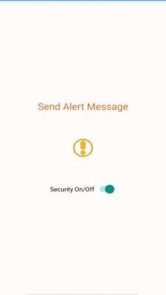Fig. 1 - Main activity window of the application

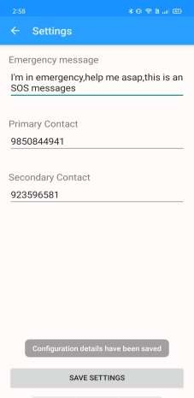Fig. 2 - The page to save emergency contact numbers and save them

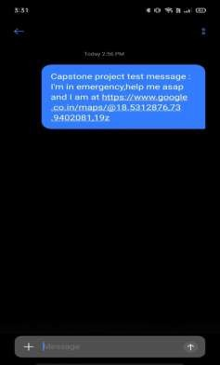Fig. 3 - The message delivered to the saved contact numbers

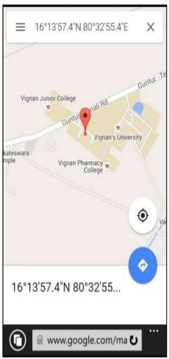Fig. 4 - Current location of the user from the test message

# Conclusion

This project focuses on providing security to users which includes location-based services, SMS services, GPS services and system Architecture. Throughout the development of the first phase of the project, we have learned much more new skills ranging from vital experience in working as a team and the new technologies. In this paper, we have described an Android Application for the safety of women. This application helps in live tracking of the location of the victim through GPS along with one of the registered contacts receives a call from the root device. The merit of this application is even when the location of the root device is changing rapidly, we can identity the exact location. As a future scope, this application can be integrated with the law enforcement database, which includes all the phone numbers of regional cops. Some use cases such as rescuing victim, when the mobile network is not available, after initial alert or switch off condition. Further, it can be developed for android and Windows mobile platforms. Thus, this application can help the women in a big way from unsafe conditions.

# Acknowledgment

The satisfaction that accompanies that the successful completion of any task would be incomplete without the mention of people whose ceaseless cooperation made it possible, whose constant guidance and encouragement crown all efforts with success. We are grateful to our project guide Mrs. V R Sonar for the guidance, inspiration and constructive suggestions that helpful us in the preparation of this project. We also thank our colleagues who have helped in successful completion of the project. We thank our principal S. K. Giram, our HOD Mr V N Kukre for their constant help and assistance.

# References

[1] IEEE paper 2020 ,title:IOT Based Women Security: A Contemplation.

[2] Report of the Fourth World Conference on Women. New York, United Nations, 1995

(A/CONF.177/20/Rev.1) (http://www.un.org/womenwatch/confer/beijing/reports/, accessed 1 April 2013).

[3] World Health Organization, “Global and regional estimates of violence against women: prevalence and

http://www.mappsafe.com/blog-1-feb-14-three-reasons-why-mobile-technology-will-reduce-violence-againstwomen.

[4] Nicole Westmarland, MariannHardey, et al. “Protecting Women‟s Safety? The use of smartphone „apps‟ in relation

to domestic and sexual violence‟, Durham University, Durham centre for research into violence and abuse (2013).

[5] Mason, C and Shoshana Magnet, “Surveillance studies and violence against women”, surveillance & society

10(2):105 –118 (2012).

[6] Justine A. Dunlap, Intimate Terrorism and Technology: There's an App for That, 7 U. Mass. L. Rev. 10 (2012).

[7] Elliott, J. and McCartan K. The Reality of Trafficked People‟s Access to Technology. The Journal of Criminal Law

77(3): 255-273(2013).

[8] Dimond, J.P., Fiesler, C.andBruckman, A.S. Domestic violence and information communication

technologies, Interacting with Computers, 23(5): 413-421(2011).

[9] Portio Research. Portio research mobile factbook 2011. Chippenham, UK. Retrieved from

http://www.portioresearch.com/Portio%20Research%20Ltd%20Mobile%20Factbook%202011.pdf (2011).

[10] Ofcom. Children and Parents: Media Use and Attitudes Report (2012).

[11] Dennison, L., Morrison, L., Conway, G., & Yardley, L. (2013).Opportunities and Challenges for

Smartphone Applications in SupportingHealthBehavior Change: Qualitative Study, Journal of medical Internet

research, 15(4): e86.

[12] Qualcomm Wireless ReachTM, Vital Wave, and GSMA. Transforming Women‟s Livelihoods Through Mobile

Broadband. Report, February 2014. Available at:http://www.qualcomm.com/mwomenreport

International Journal of Innovative Research in Science, Engineering and Technology

[13] Vamil B. Sangoi, “Smart security solutions,” International Journal ofCurrent Engineering and Technology, Vol.4,

No.5, Oct-2014.

[14] B.Chougula, “Smart girls security system,” International Journal ofApplication or Innovation in Engineering &

Management, Volume 3, Issue 4,April 2014.

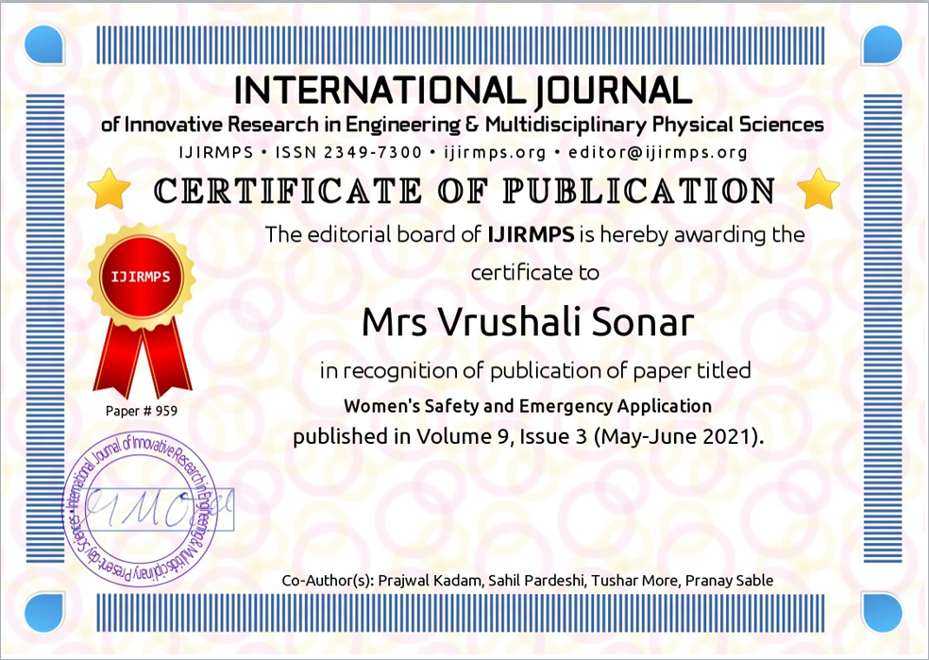

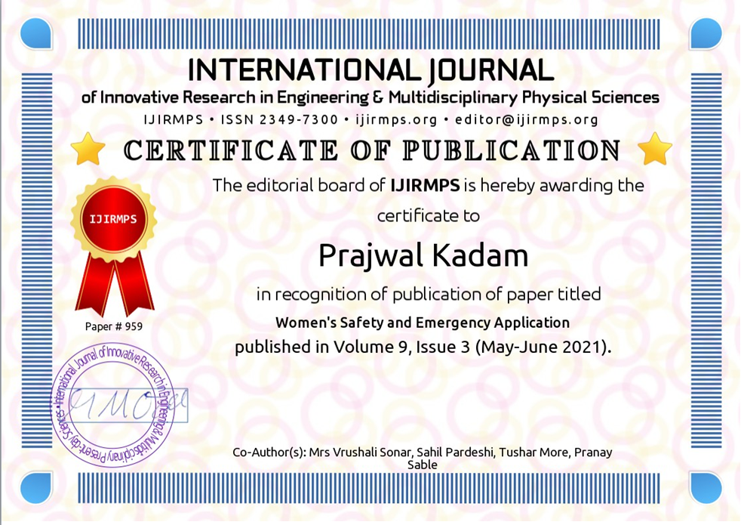





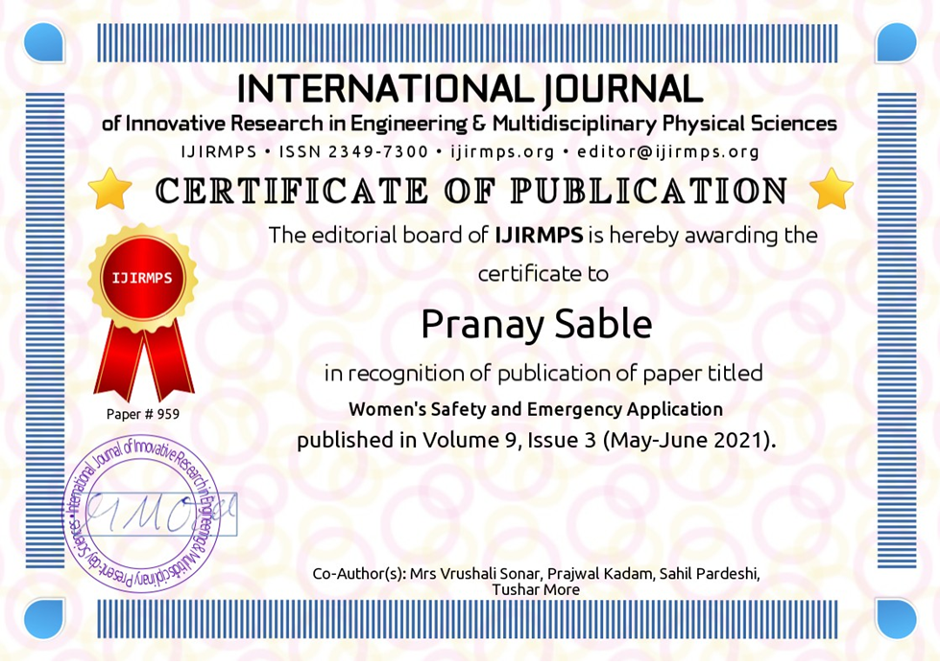

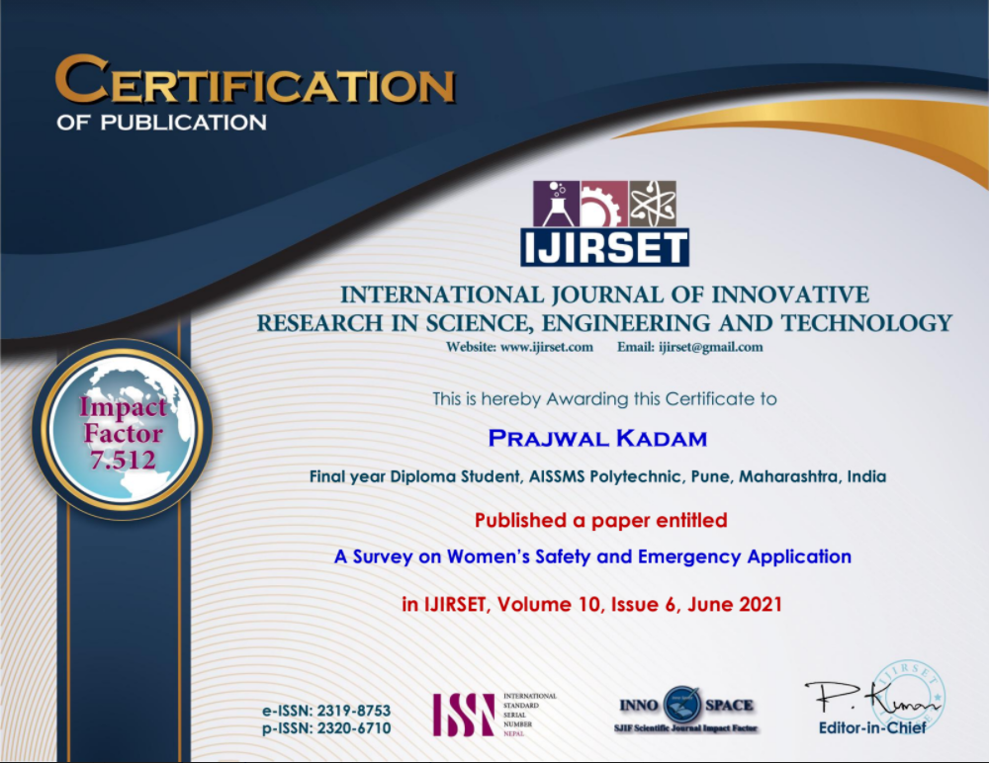



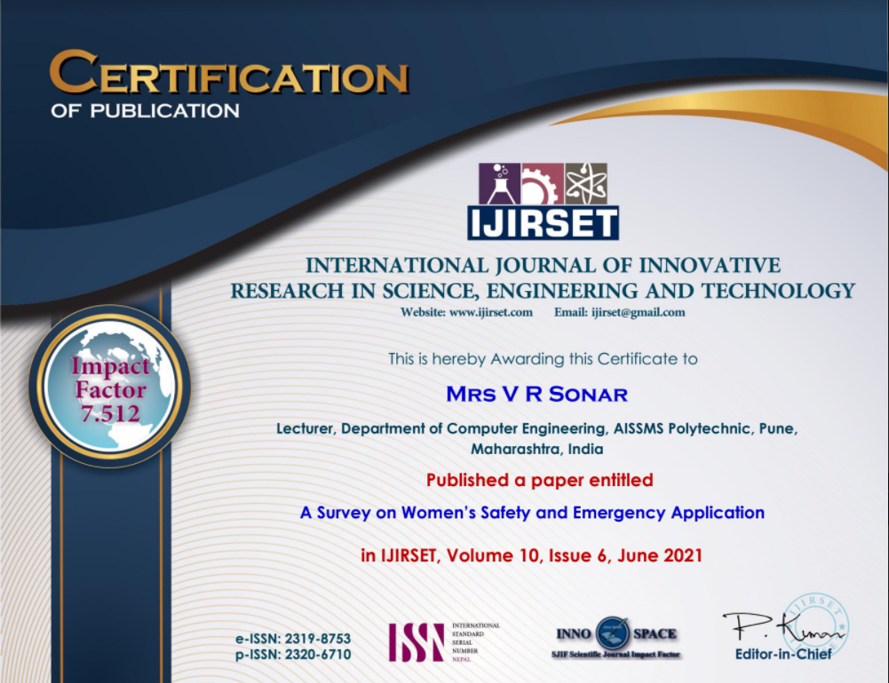

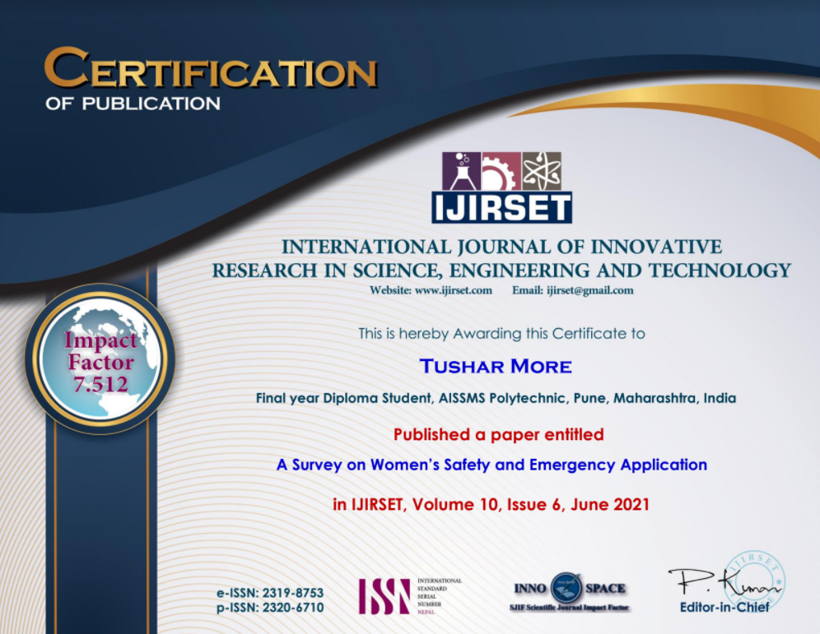



**Chapter 9**

**References and Bibliography**

**9.0 References:**

[1] IEEE paper 2020 ,title:IOT Based Women Security: A Contemplation.

[2] Report of the Fourth World Conference on Women. New York, United Nations, 1995

(A/CONF.177/20/Rev.1) (http://www.un.org/womenwatch/confer/beijing/reports/, accessed 1 April 2013).

[3] World Health Organization, “Global and regional estimates of violence against women: prevalence and

http://www.mappsafe.com/blog-1-feb-14-three-reasons-why-mobile-technology-will-reduce-violence-againstwomen.

[4] Nicole Westmarland, MariannHardey, et al. “Protecting Women‟s Safety? The use of smartphone „apps‟ in relation

to domestic and sexual violence‟, Durham University, Durham centre for research into violence and abuse (2013).

[5] Mason, C and Shoshana Magnet, “Surveillance studies and violence against women”, surveillance & society

10(2):105 –118 (2012).

[6] Justine A. Dunlap, Intimate Terrorism and Technology: There's an App for That, 7 U. Mass. L. Rev. 10 (2012).

[7] Elliott, J. and McCartan K. The Reality of Trafficked People‟s Access to Technology. The Journal of Criminal Law

77(3): 255-273(2013).

[8] Dimond, J.P., Fiesler, C.andBruckman, A.S. Domestic violence and information communication

technologies, Interacting with Computers, 23(5): 413-421(2011).

[9] Portio Research. Portio research mobile factbook 2011. Chippenham, UK. Retrieved from

http://www.portioresearch.com/Portio%20Research%20Ltd%20Mobile%20Factbook%202011.pdf (2011).

[10] Ofcom. Children and Parents: Media Use and Attitudes Report (2012).

[11] Dennison, L., Morrison, L., Conway, G., & Yardley, L. (2013).Opportunities and Challenges for

Smartphone Applications in SupportingHealthBehavior Change: Qualitative Study, Journal of medical Internet

research, 15(4): e86.

[12] Qualcomm Wireless ReachTM, Vital Wave, and GSMA. Transforming Women‟s Livelihoods Through Mobile

Broadband. Report, February 2014. Available at:http://www.qualcomm.com/mwomenreport

International Journal of Innovative Research in Science, Engineering and Technology (IJIRSET)

| e-ISSN: 2319-8753, p-ISSN: 2320-6710| www.ijirset.com | Impact Factor: 7.512|

||Volume 10, Issue 6, June 2021||

|DOI:10.15680/IJIRSET.2021.1006105|

IJIRSET © 2021 | An ISO 9001:2008 Certified Journal | 6448

[13] Vamil B. Sangoi, “Smart security solutions,” International Journal ofCurrent Engineering and Technology, Vol.4,

No.5, Oct-2014.

[14] B.Chougula, “Smart girls security system,” International Journal ofApplication or Innovation in Engineering &

Management, Volume 3, Issue 4,April 2014.